Experiment 19:
Aim:
19.Write a Pandas program to display the dimensions or shape of the World alcohol consumption dataset. Also extract the column names from the dataset.
Python code:
import pandas as pd

# Read the World Alcohol Consumption dataset
df = pd.read_csv("world_alcohol.csv")

print("Original DataFrame:")
print(df)

# Display the shape (dimensions) of the dataset
print("\nShape of the dataset:")
print(df.shape)

# Extract the column names
print("\nColumn names:")
print(df.columns.tolist())
Output:
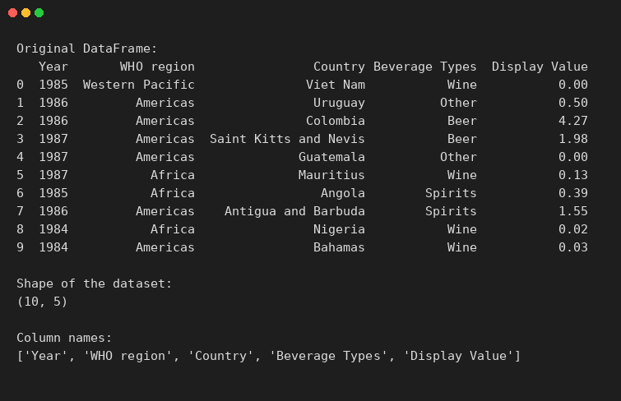
Experiment 20:
Aim:
20.Write a Pandas program to find the index of a given substring of a DataFrame column.
Python code:
import pandas as pd

# Create DataFrame
data = {
"name_code": ["c001", "c002", "c003", "c004"],
"name": ["Alberto Franco", "Gino Mcneill", "Ryan Parkes", "Eesha Hinton"]
}
df = pd.DataFrame(data)
print("Original DataFrame:")
print(df)

# Find the index of a given substring in the 'name' column
substring = "o"
df["Index"] = df["name"].str.find(substring)
print(f"\nIndex of the substring '{substring}' in each name:")
print(df)
Output:
